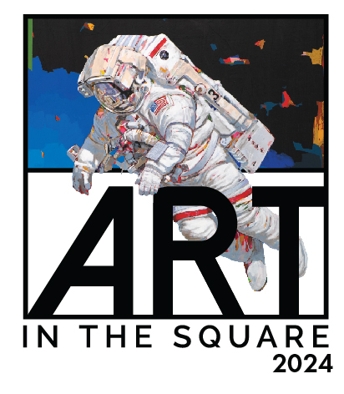
Art in the Square is a cosmic canvas!
The 24th Art in the Square lifts off with Methodist Southlake Medical Center as presenting sponsor. Art in the Square is a national award-winning festival with a ranking of #4 for 2024. Come to Southlake Town Square on April 26-28 with family and friends for a fun-filled weekend of abundant art, music, tasty food, refreshing spirits and children’s activities.
Southlake Women’s Club is showcasing the remarkable artwork of 150 juried renowned artists. Visit “Arts Alive,” Apex Arts League photo op stop for snap shots.
Tour the Youth Art tent to view the exceptional artwork of the high school students of Northeast Tarrant County. New this year on May 2nd, Methodist Southlake is hosting a reception showcasing the Art in the Square Youth Art winners and outstanding young artists from surrounding school districts.
NEW destination areas coming! THE VINEYARD ON GRAND in Le Bistro will be pouring specialty wines. Main Street Eatery will offer additional dining choices.
The Methodist Southlake Medical Center Main Stage hosts a playbill of free performances radiating energy from all genres throughout the weekend. Friday night, April 26 at 8:30 pm Mike Barbee, a popular DJ in the area will engage and entertain the audience. Saturday, April 27 at 8:30 pm. Free Fallin, THE TOM PETTY CONCERT EXPERIENCE electrifies the audience as they perform the sounds of Tom Petty.
Community stars from schools, performing art studios, dance groups and more will perform on the Texas Health Hospital Southlake Gazebo Stage.
Kid’s Korner and The Zone will require parents to purchase tickets by credit card for each activity. In Kids Korner sponsored by Cook Children’s offers numerous activities for creativity. The Zone creates laughable fun bouncing, climbing, jumping and sliding.
Be an ARTWALKER in the cosmic canvas, April 26-28. Where else can you experience art, entertainment, and family fun while helping 26 charities in the community? www.artinthesquare.com.
Submitted by
Sherri Whitt, Marketing/Publicity
Sjwswc1@aol.com

