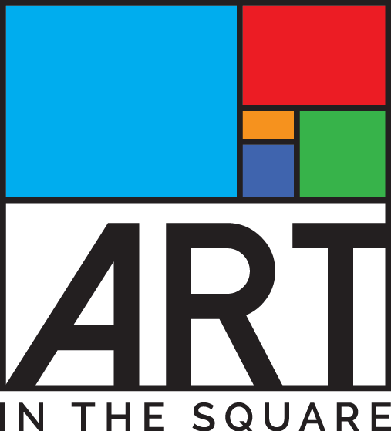
Sponsor / Underwriter Acknowledgement Form

Juried Art Festival with Food & Music * April 27-29, 2018 * Southlake Town Square

Jointly Hosted by the Southlake Women’s Club, Southlake Town Square & City of Southlake

PLEASE FILL OUT THIS FORM COMPLETELY AND RETURN TO ADDRESS BELOW

Date

Sponsor/Organization Name

Sponsor Address/

City, State, Zip
Telephone |  | Fax

E-mail

Contact Person (Tent/Banner/Kickoff Party)

Donor Signature

LEVEL | CASH & GOODS / SERVICES
- PRESENTING STAGE SPONSOR | $15,000+ CASH

Y / N Reserve optional promotional space?

10’x20’ booth space (tent included)
- PRODUCING Media SPONSOR*  *Restrictions apply to media partners | $15,000 - $25,000

Y / N Reserve optional promotional space?

10’x20’ booth space (tent included)
- MARQUEE SPONSOR  *Restrictions apply to media partners | $10,000 - $14,999

Y / N Reserve optional promotional space?

10’x10’ booth space (tent included)
- MUSEUM SPONSOR | $5,000 - $9,000

Y / N Reserve optional promotional space?

10’x10’ booth space (tent included)
- GALLERY SPONSOR | $3,000 - $4,999

Y / N Reserve optional promotional space?

10’x10’ booth space (tent included)
- SHOWCASE SPONSOR | $1,000 - $2,999

Y / N Will you provide company banner for display?
- PATRONS OF THE ARTS | $500 - $999
- Please either enclose check payable to Southlake Women’s Club Foundation, Inc. or state amount and when we should expect the payment: Amount: $ ___________ Date_________
- For sponsors providing donated services and goods, please complete the Donor Record of Services and Goods Form to explain the value such items and services.
Mail check and form(s) to: Southlake Women’s Club Foundation, Inc.,
ATTN: Sponsorship Chairman, Carmen Evans
P.O. Box 92611 Southlake, TX 76092
817-320-4672 sponsorship@artinthesquare.com

