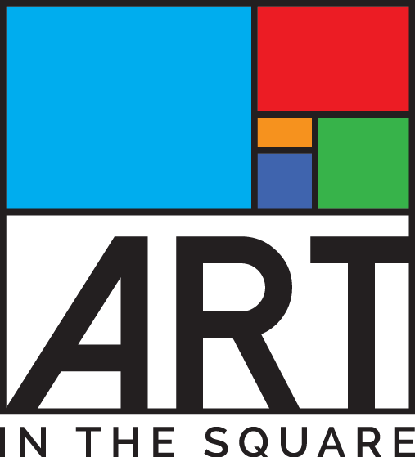
Sponsor / Underwriter Acknowledgement Form

Juried Art Festival with Food & Music * April 26-28, 2019* Southlake Town Square

Jointly Hosted by the Southlake Women’s Club, Southlake Town Square & City of Southlake

PLEASE FILL OUT THIS FORM COMPLETELY AND RETURN TO ADDRESS BELOW

Date

Sponsor/Organization Name

Sponsor Address

City, State, Zip
Telephone |  |  | Fax

E-mail

Contact Person (Tent/Banner/Kickoff Party)

Donor Signature

LEVEL | CASH & GOODS / SERVICES
- PRESENTING STAGE SPONSOR | $15,000+ CASH

Y / N Reserve optional promotional space?

10’x20’ booth space (tent included) SOLD
- PRODUCING Media SPONSOR*  *Restrictions apply to media partners | $15,000 - $25,000

Y / N Reserve optional promotional space?

10’x20’ booth space (tent included)
- MARQUEE SPONSOR  *Restrictions apply to media partners | $10,000 - $14,999

Y / N Reserve optional promotional space?

10’x10’ booth space (tent included)
- MUSEUM SPONSOR | $5,000 - $9,000

***Exclusive Gazebo Stage $7,500 SOLD

***Limited Prime Corner locations $5,000

Y / N Reserve optional promotional space?

10’x10’ booth space (tent included)
- GALLERY SPONSOR | $3,000 - $4,999

Y / N Reserve optional promotional space?

10’x10’ booth space (tent included)
- SHOWCASE SPONSOR | $1,000 - $2,999

Y / N Will you provide company banner for display?
- PATRONS OF THE ARTS | $500 - $999
- Please either enclose check payable to Southlake Women’s Club Foundation, Inc. or state amount and when we should expect the payment: Amount: $ __________ Date____________
- For sponsors providing donated services and goods, please complete the Donor Record of Services and Goods Form to explain the value of such items and services.

Mail check and form(s) to: Southlake Women’s Club Foundation, Inc.,
ATTN: Sponsorship Chairman, Carmen Evans
P.O. Box 92611
Southlake, TX 76092
817.320.4672
sponsorship@artinthesquare.com

